**ONLINE FOOD Top of Form**

**RESTAURANT**

SIGNATURE RESTAURANT

**Group Members Information**

|  |  |
| --- | --- |
| **NAME** | **REGISTRATION NO.** |
| 1. MIRZA AMJAD ALI BAIG | 2025-CS-267 |
| 1. MUHAMMED ALI MUNIR | 2025-CS-270 |
| 1. NORAIZ KHAN | 2025-CS-282 |
| 1. MUHAMMED HASEEB | 2025-CS-276 |
| 1. ZAMAN ABBAS | 2025-CS-285 |
|  |  |

**Course:** AICTL

**Instructor Name:** RAMSHA KHALID

**Dated:** 08-01-2026

**TABLE OF CONTENTS**

**1.** **EXECUTIVE SUMMARY** 2

**2.** **PROJECT OBJECTIVES & SCOPE** 3

**2.1** **Project Objectives** 3

**2.2** **Scope of Project** 3

**3.** **SITE STRUCTURE AND NAVIGATION** 3

**3.1** **Site Structure** 3

**3.1.1** **Home** 4

**3.1.2** **Login** 4

**3.1.3** **Menu** 5

**3.1.4** **Cart** 5

**3.1.5** **Gallery** 5

**3.1.6** **About Us** 6

**3.1.7** **Contact Us** 6

**3.2** **Navigation** 7

**4.** **DESIGN CHOICES** 7

**4.1** **Design** 7

**4.2** **Fonts** 7

**4.3** **Colour Scheme** 7

**4.4** **Layout and Structure** 8

**4.5** **Navigation Design** 8

**4.6** **Responsiveness and Simplicity** 8

**5.** **ASSETS USED** 8

**5.1** **Images** 8

**5.1.1** **Website Images** 8

**5.1.2** **Image Source** 15

**5.2** **Data Sources** 15

**5.3** **Files used inside the project** 16

**6.** **HOW TO RUN/PUBLISH THE SITE** 16

**6.1** **Running the Website Locally** 16

**6.2** **Publishing the Website Online** 16

**7.** **REFLECTION** 17

**7.1** **Learning outcomes** 17

**7.2** **Improvements to be done** 17

# **EXECUTIVE SUMMARY**

This project is about creating a static website for an online food restaurant. The site will be developed using only HTML5 and CSS3 technologies. No JavaScript will be used to keep the site simple and to ensure it works fast. The main goal is to build a professional digital presence that visually represents the restaurant's login page, menu, gallery, cart, contact and about page details while being easily accessible and user, friendly for potential customers. The technical side of this project is all about minimalistic development which leads to quick loading times and good search engine optimization potential because of the clean HTML structure. This static website design does not require any server, side processing or database management, thus cutting development costs and the complexity of maintenance. The execution will be organized starting with planning and wireframing, then CSS styling and responsive layout creation, HTML development and content integration, exhaustive testing for cross, and browser compatibility. The goals are to get the restaurant more visible online, engage customers more through a professional digital presence, build a strong brand image, and lay the groundwork for future website enhancements.

# **PROJECT OBJECTIVES & SCOPE**

## **Project Objectives**

The main objectives of the Online Restaurant are:

1. To develop **a user-friendly online platform** that allows customers to browse restaurant menus and place food orders easily.
2. To provide customers with **detailed information** about food items, including prices, descriptions, and images.
3. To design an online restaurant website that allows customers to **place food orders instead of standing in long queues**.
4. To provide customers with the facility to **order food from their homes and receive it at their doorstep**.
5. To display restaurant menu items clearly so customers can **view food options before visiting the restaurant**.
6. To save customers’ time by offering a **quick and convenient online ordering interface**.
7. To provide complete information about food items, including **prices and images**, through a single platform.
8. To create a **simple and attractive website layout** using HTML and CSS.
9. To make the restaurant services **easily accessible through any device** using a responsive design

## **Scope of Project**

We have covered the following points in the scope of this project:

1. A responsive website layout designed using HTML5 and external CSS.
2. Home page displaying restaurant highlights.
3. Menu page showing food items with images, names, descriptions, and prices.
4. About page describing the restaurant and its services.
5. Gallery section displaying food images.
6. Contact page with a static contact form.
7. Navigation bar for easy movement between pages.
8. Use of CSS Flexbox or Grid for page layout.

# **SITE STRUCTURE AND NAVIGATION**

## **Site Structure**

The structure of the website is divided into seven pages.

* Home
* Login
* Menu
* Cart
* Gallery
* About us
* Contact us

### **Home**

The **Home page** is the main entry point of the website. It introduces the online food ordering system and creates the first impression for users. This page highlights the brand name, attractive food visuals, and key features of the service. It provides quick navigation **links** to other pages such as **Login, Menu, Cart, Gallery, About Us,** and **Contact Us**, allowing users to easily explore the website.

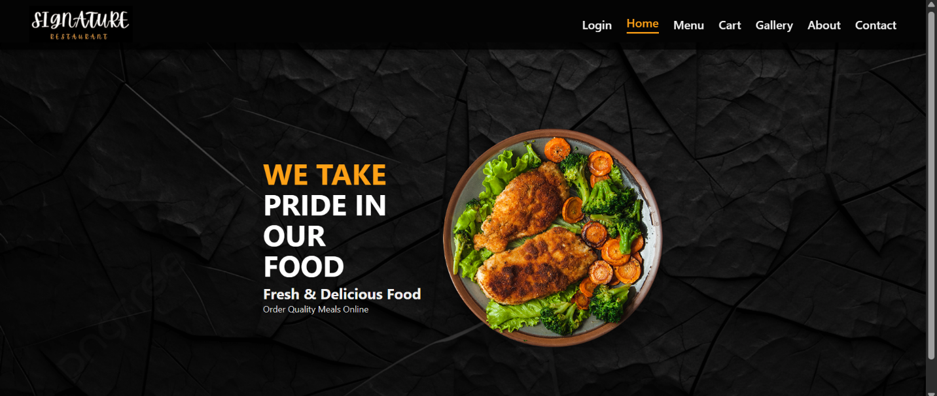

### **Login**

The **Login page** allows registered users to securely access their accounts. Users can enter their credentials like **username** and **password** to log in and place orders. This page ensures **authentication** and protects user data. New users may also be guided to register before accessing the services.

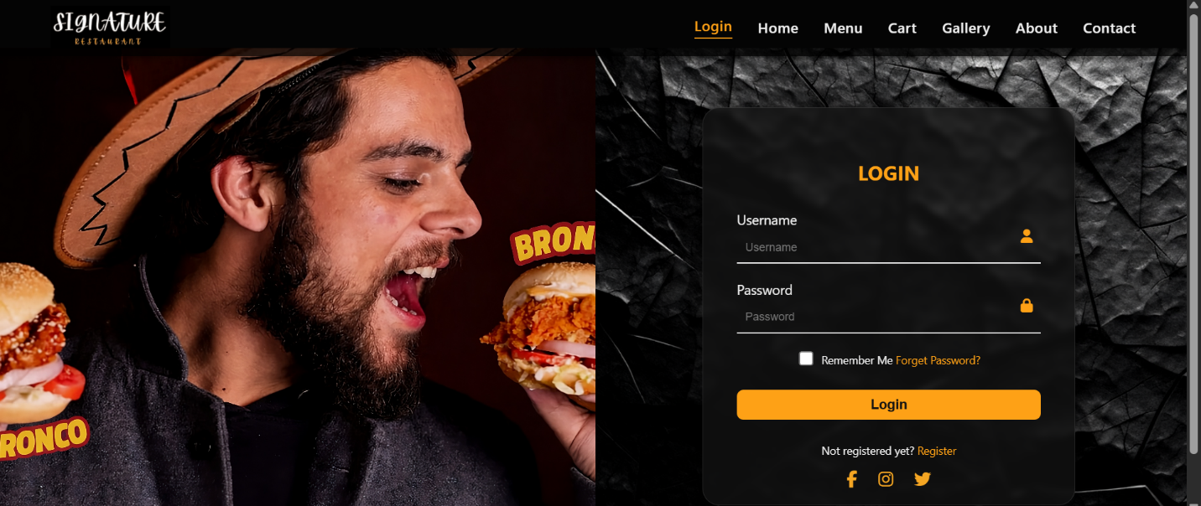

### **Menu**

The **Menu page** displays a complete list of available food items along with their prices and descriptions. Users can browse different foods, select their desired items, and add them to the cart. This page plays a central role in the ordering process by helping users make food choices easily.

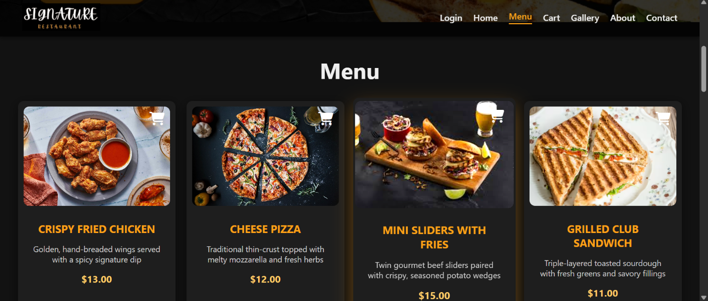

### **Cart**

The **Cart page** shows the selected food items added by the user. It allows users to **review** their order, check item prices. This page helps ensure order accuracy before **checkout**.

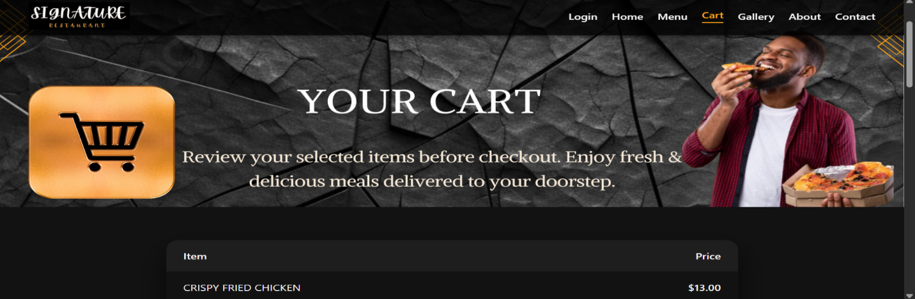

### **Gallery**

The **Gallery page** presents images of **food items** like chicken dishes, beef dishes, sweets, salads alongside and special dishes. It enhances user engagement by visually representing the quality and variety of food offered, helping users feel more confident in their selection.

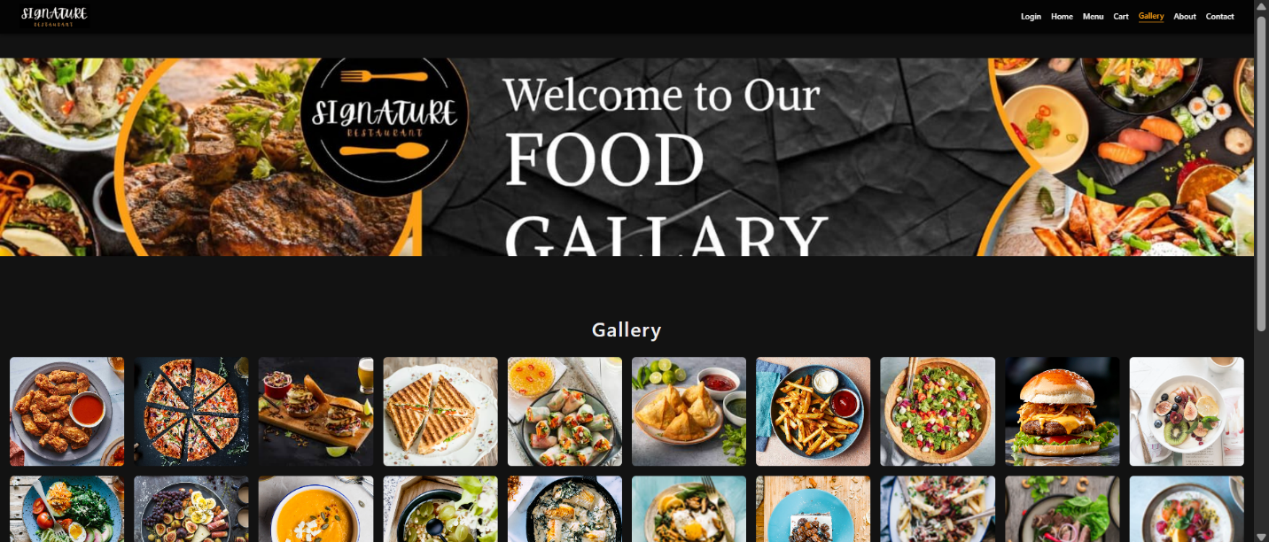

### **About Us**

Background info, mission statement, and brand story. The **About Us page** provides information about the restaurant or service provider. It explains the **mission, vision,** and **purpose** of the online food ordering system. It introduces the **founders** of the company. Background info, mission statement, and brand story. This page helps build trust and credibility with users.

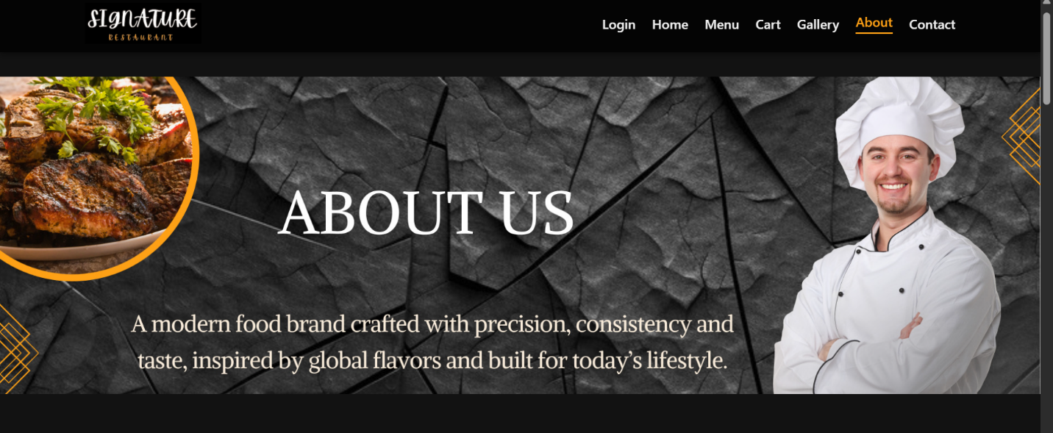

### **Contact Us**

The **Contact Us page** enables users to communicate with the service provider. It includes contact details such as **phone number, email address, a map** and **inquiry form**. This page ensures customer support and improves user satisfaction. You can also communicate us via our social media apps like **Instagram, Facebook, Twitter** etc.

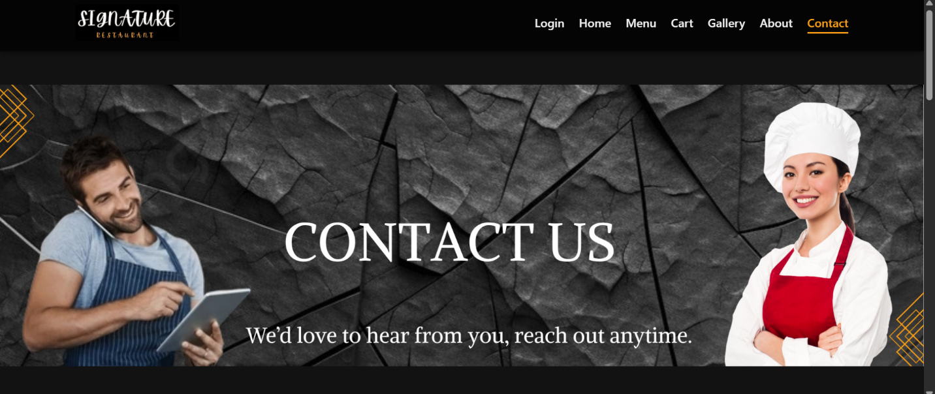

## **Navigation**

The navigation bar, located at the top of every page, serves as the primary roadmap for the website. It provides consistent, one-click access to all major sections, including the **Menu**, **Login**, **Gallery**, **Contact Us** and **About Us** pages. No matter where a user is on the site, they can return to the **Home** page or access their **Cart** instantly via this persistent header.



# **DESIGN CHOICES**

## **Design**

The design of the website was carefully planned to ensure usability, readability, and a visually appealing user experience. All design elements were selected to support the purpose of an online food ordering system and to make navigation simple for users.

## **Fonts**

The website uses **Alike, Aptos body,** as the primary font. This font was selected because it is professional, easy to read, and commonly used in formal documents and academic projects. Consistent font size and style are maintained across all pages to ensure uniformity and clarity. The logo is made by using **Apricots** font.

## **Colour Scheme**

A simple and clean colour scheme was chosen for the website. Light background colours are used to improve readability, while darker text colours provide clear contrast. Food-related accent colours like orange colour are used where necessary to attract user attention without making the interface visually crowded.

## **Layout and Structure**

The website follows a **clean and structured layout**. Each page is divided into clear sections such as header, content area, and footer. The navigation menu is placed prominently to allow users to move easily between pages. Adequate spacing and alignment are used to make content easy to scan and understand.

## **Navigation Design**

Navigation is kept simple and user-friendly. All major pages (Home, Login, Menu, Cart, Gallery, About Us, and Contact Us) are accessible from the main navigation menu. This design ensures that users can reach any page with minimal clicks.

## **Responsiveness and Simplicity**

The design focuses on simplicity to ensure smooth performance across different devices and screen sizes. Unnecessary visual elements were avoided to keep the website fast, clear, and easy to use.

# **ASSETS USED**

The website uses various assets to enhance functionality and appearance. Food images were used to visually represent menu items and improve user engagement. These images were obtained from free online resources. Sample data such as food names, prices, and descriptions were used for demonstration purposes only. All assets were selected carefully to support the design and purpose of the website.

## **Images**

### **Website Images**

* Logo image:



* Background image:



* Login image:

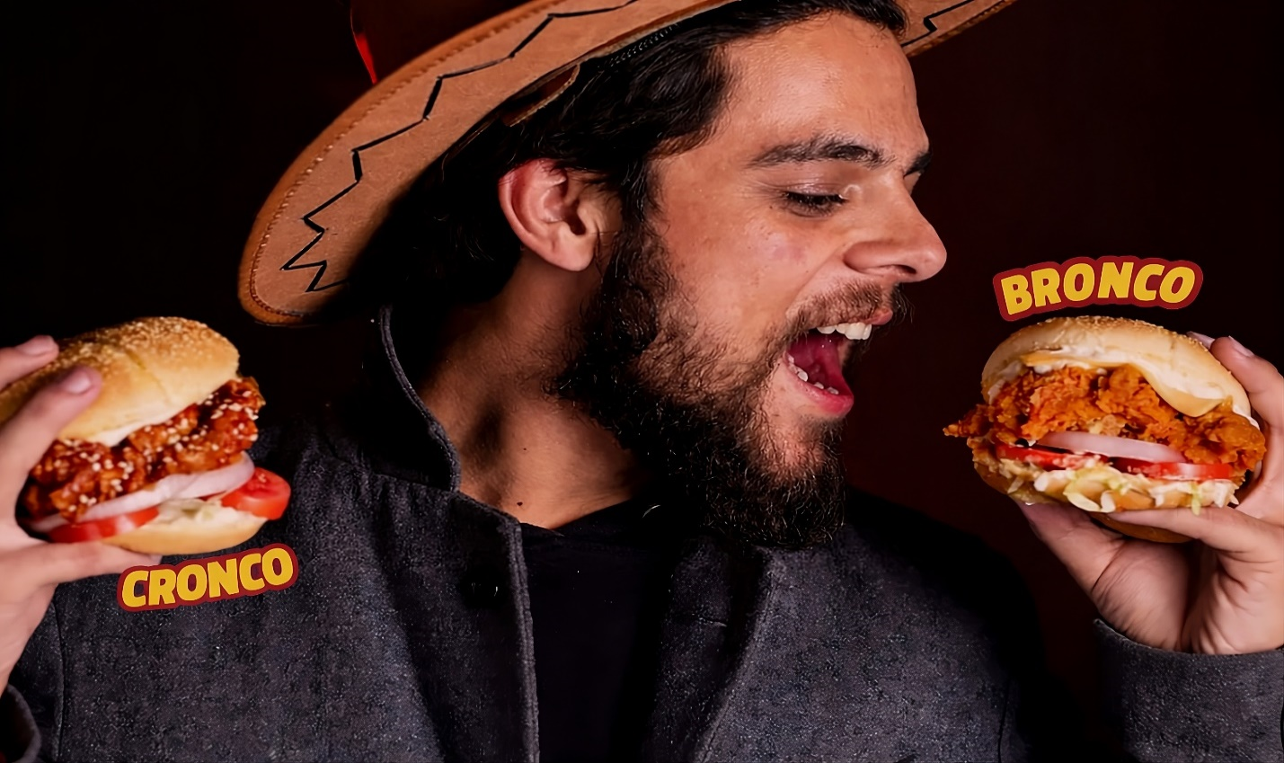

* Hero-section images:

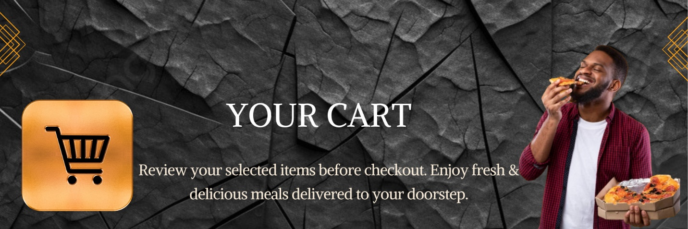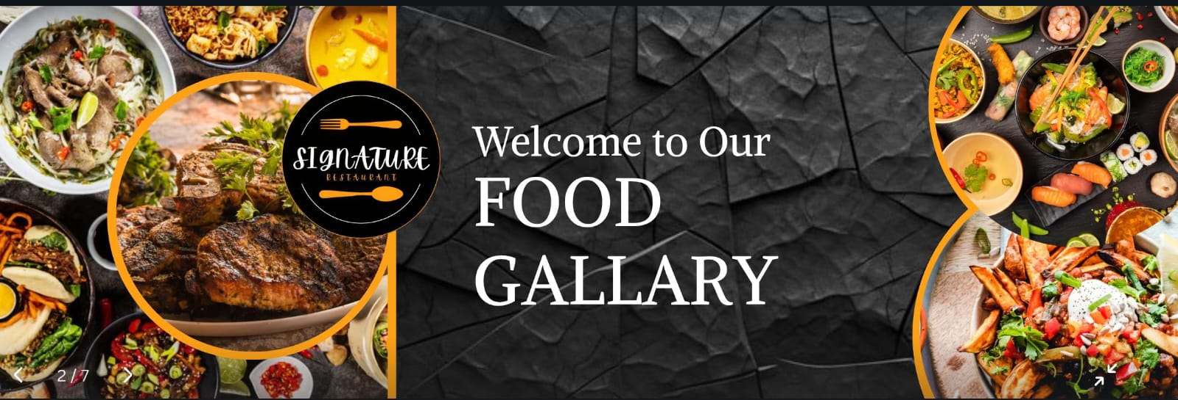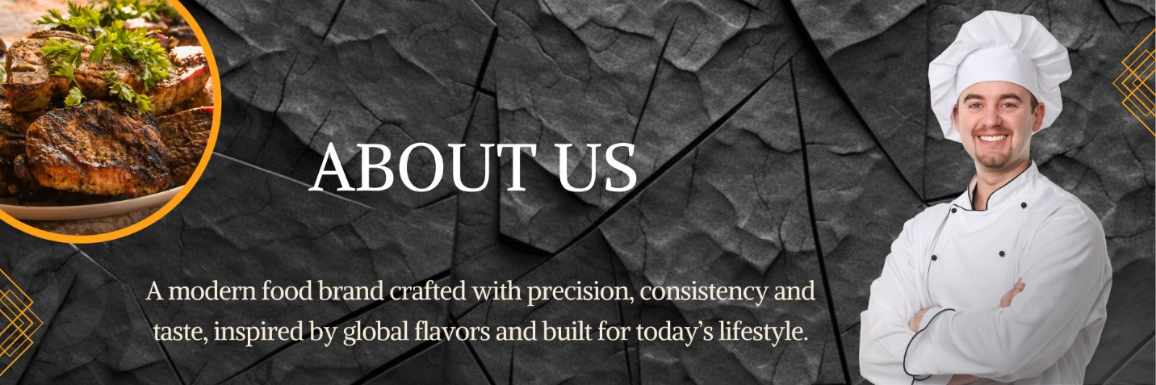

* Menu image:

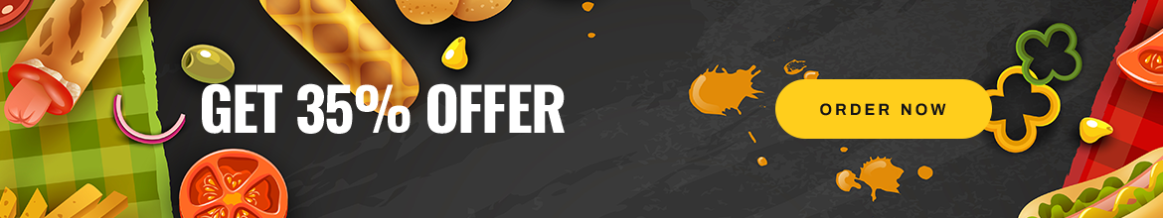

* Food images:

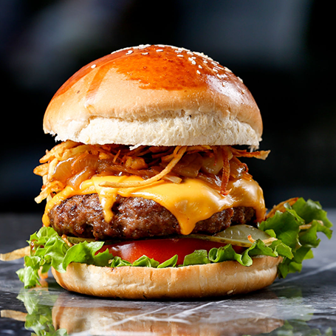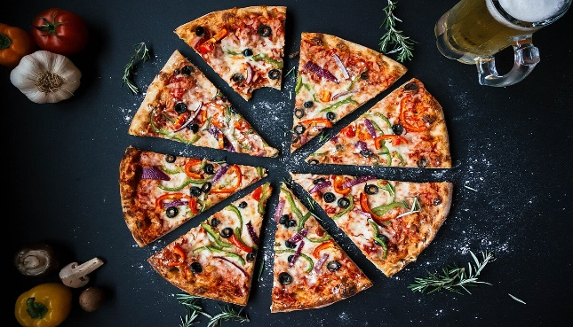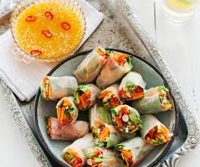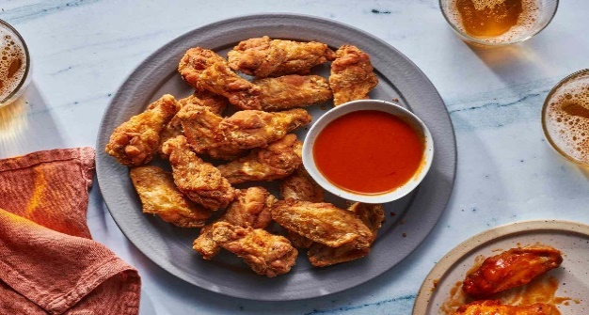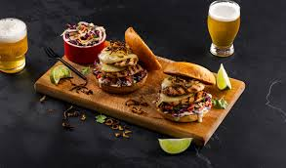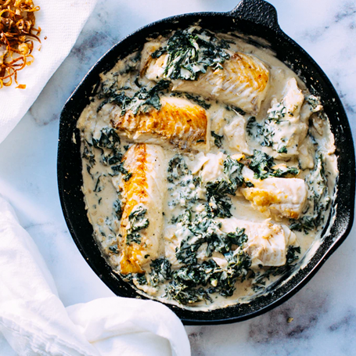

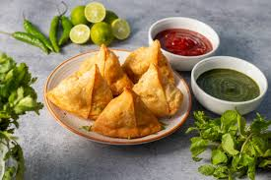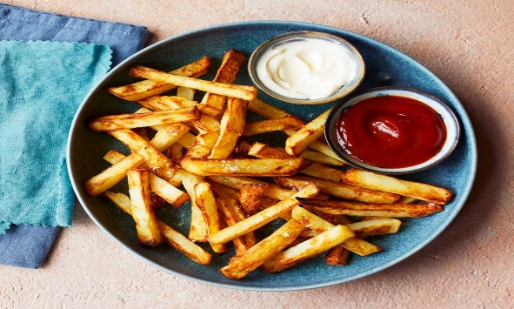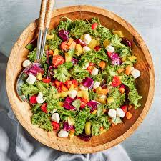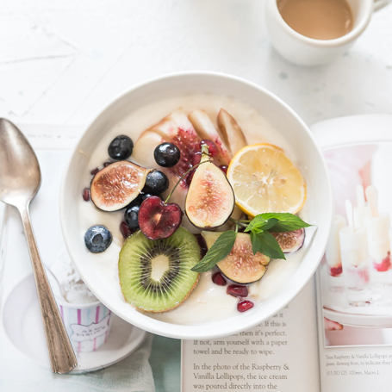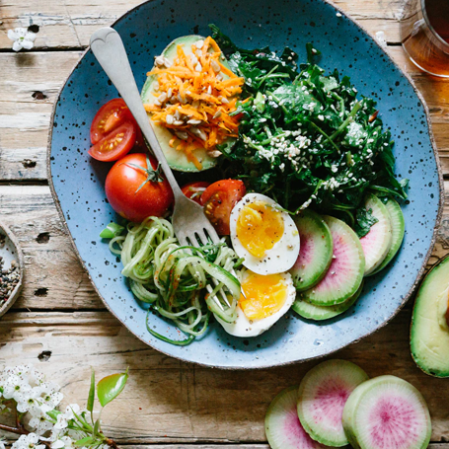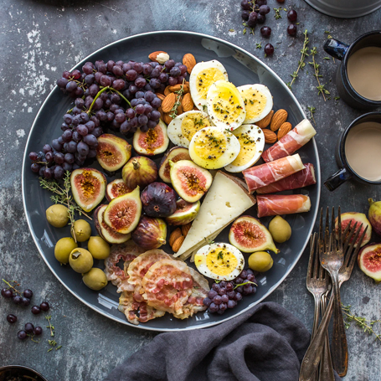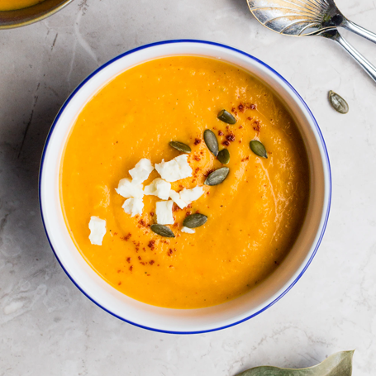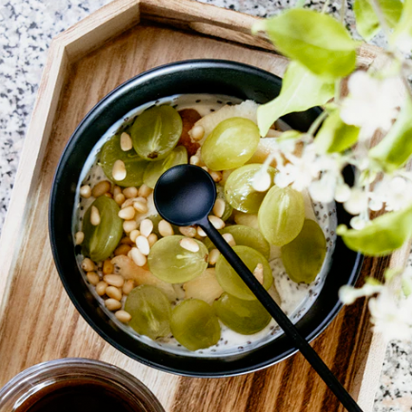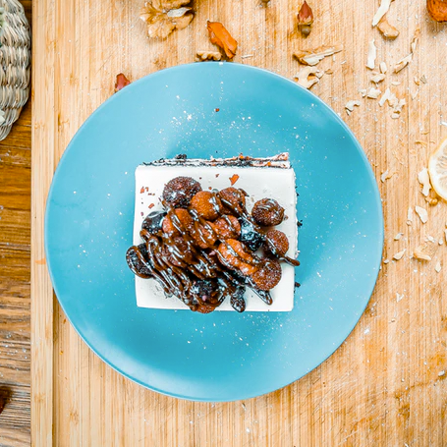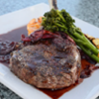

* Gallery photos:

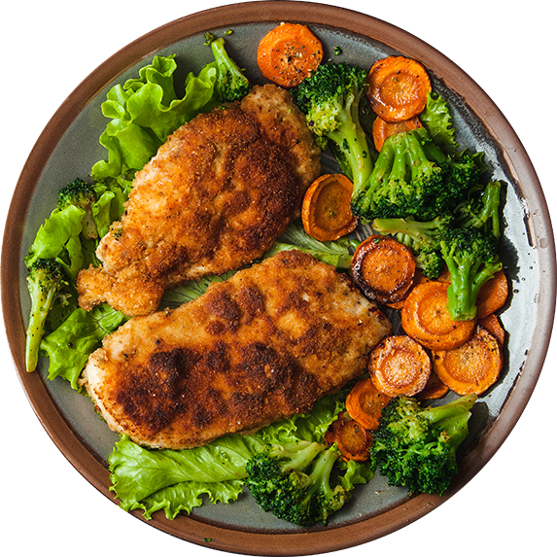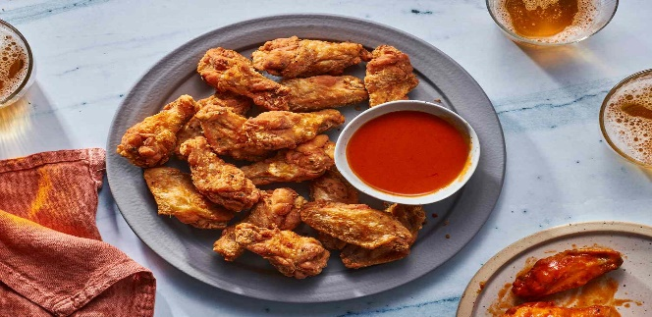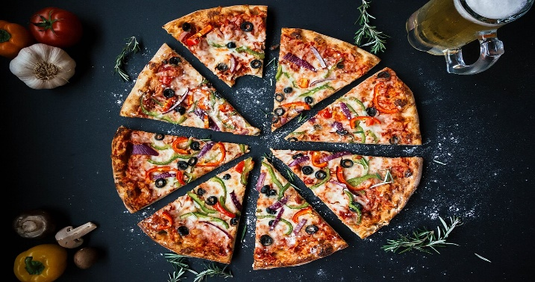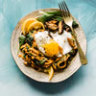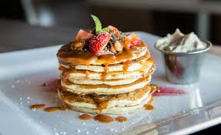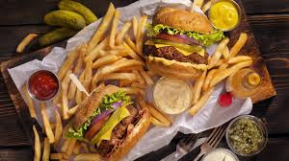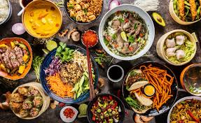

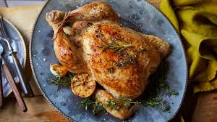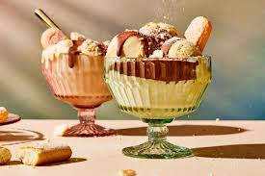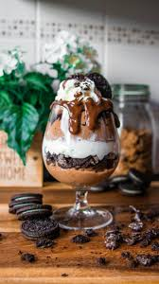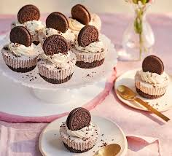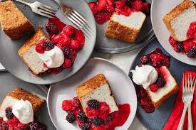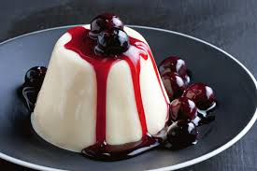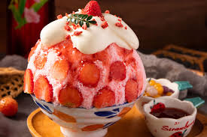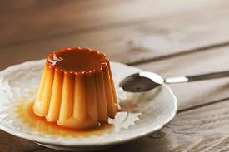

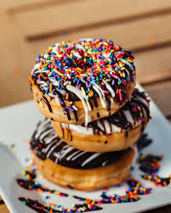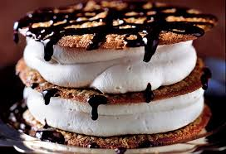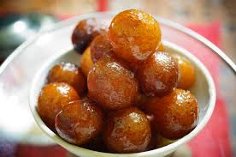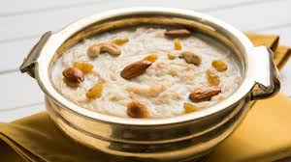

### **Image Source**

* Logo image: The **website logo (logo.jpg)** was custom-designed by the team.
* Background image: Image was taken from **online free food picture website**.
* Login page: Background image (login1.jpg) was downloaded from **Pexels** and optimized for web use.
* Food images: Food images were taken from free stock image websites such as **Unsplash** and Pexels.
* Hero-section: Images were created or captured by the **project team**.

## **Data Sources**

* Menu items: Menu items were manually created for academic purposes.
* Prices: All pricing data is fictional and used only for demonstration.
* Text content:
* About Us: Personal information is sample data and does not belong to real-world..
* Contact Us: Contact information is sample data and does not represent a real business.

## **Files used inside the project**

The project uses **HTML5** for structure, **CSS3** for styling, and local **image** assets stored in the images folder.

* HTML files
* index.html
* login.html
* menu.html
* cart.html
* gallery.html
* about.html
* contact.html
* CSS files
* style.css
* login.html
* menu.html
* cart.html
* gallery.html
* about.html
* contact.html
* Image folder
* Image folder named **images.**

# **HOW TO RUN/PUBLISH THE SITE**

This website is developed using only HTML and CSS; therefore, it is a static website and does not require any backend or database.

## **Running the Website Locally**

The website can be run locally by opening the index.html file in any modern web browser such as Google Chrome or Microsoft Edge. Since all pages are connected through HTML links and styled using an external CSS file, the complete website loads properly without any server setup.

## **Publishing the Website Online**

For publishing the website online, **GitHub Pages** is the best and easiest solution for static websites. First, a GitHub repository is created and all website files are uploaded to it. Then GitHub Pages is enabled from the repository settings by selecting the main branch. GitHub automatically generates a live URL, allowing the website to be accessed from anywhere using a web browser. Our website live URL:

https://2025cs267studentuet-boop.github.io/Group-08-Online-Restaurant/

GitHub Pages is suitable for static websites because it is free, easy to use, and supports HTML and CSS projects.

# **REFLECTION**

## **Learning outcomes**

During the development of this project, our team learned many practical skills related to designing and creating a static website using HTML and CSS. We learned how to add images and videos to a website and how to place them properly to enhance the overall user experience. This project helped our team understand how to create a good and responsive static website that works effectively on different screen sizes.

Our team also learned how to design a complete website theme using Canva, including selecting suitable layouts, fonts, and visual styles. Creating an attractive logo using Canva was another valuable learning experience, which helped us build a professional identity for the website. We also gained a better understanding of color contrasting and how selecting appropriate colors can make a website more readable, attractive, and user-friendly.

Additionally, our team learned how to create an impressive, impactful, and meaningful project video using various tools such as Canva, Filmora, and Spring. This experience improved our understanding of how visual presentation and storytelling play an important role in presenting a project effectively.

## **Improvements to be done**

The project could be further improved by adding backend functionality, user authentication, and real time order processing. Additional interactive features and animations could also be incorporated to further enhance the user experience. Overall, this project significantly improved our team’s skills in static website development, design, and project presentation.